**الاسم: أحمد السيد السيد محمد جمعه**

**Cs => 806326326**

Infinite Compiler…< >



* Creating Parse Table.
* **Language Grammar to Create Parse Table?**

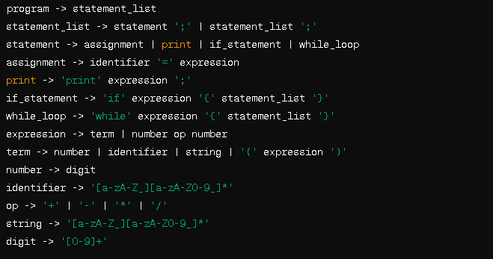

* **Terminals and Non-Terminals:**

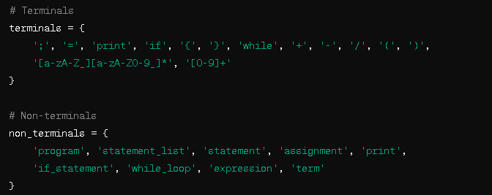

* **Constructing Parse Table using First and Follow Set:**
* **First Set:**

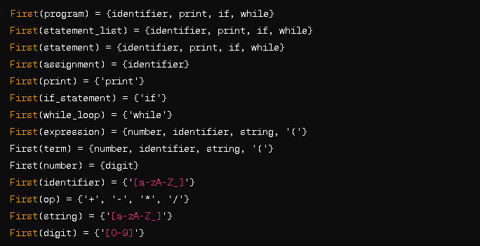

**Follow Set:**

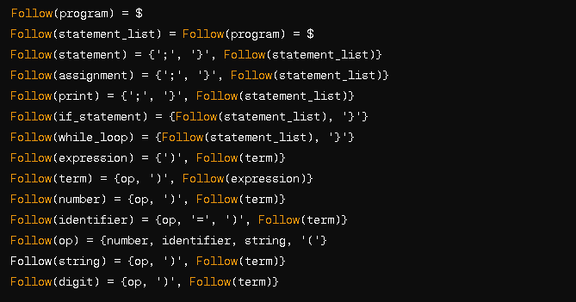

**Code for Constructing Parse Table:**

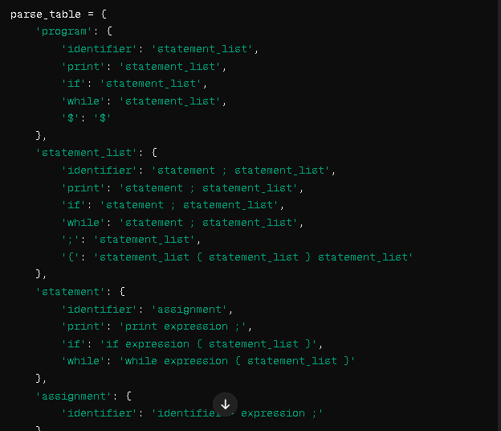

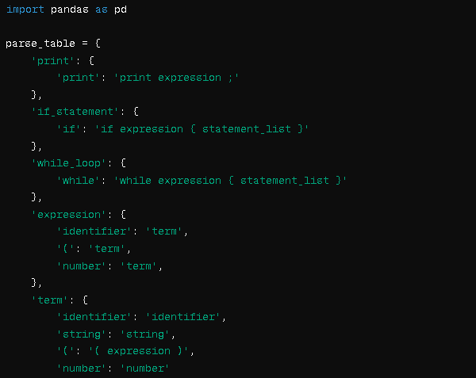

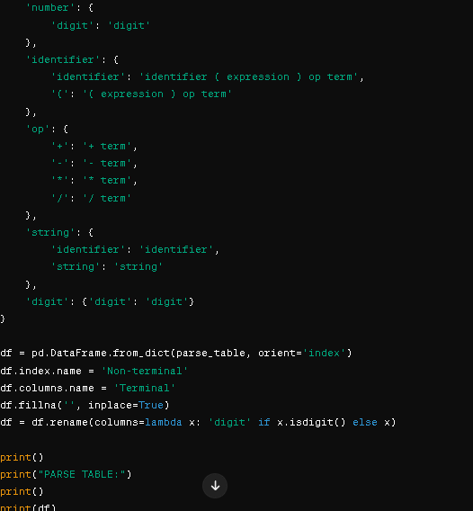

**Code Output:**

